**AIR QUALITY ANALYSIS IN TAMILNADU**

**Objectives**

Pollution acquires many forms, such as water, air, noise, heat, and light, whereas air pollution immediately affects human health. Controlling air pollution is a critical task because the sources of air pollution are more and different. Measuring and forecasting the severity level of air pollution helps the public to take safety actions immediately.

Hence measuring air pollution precisely and automatically has become the need of the hour.

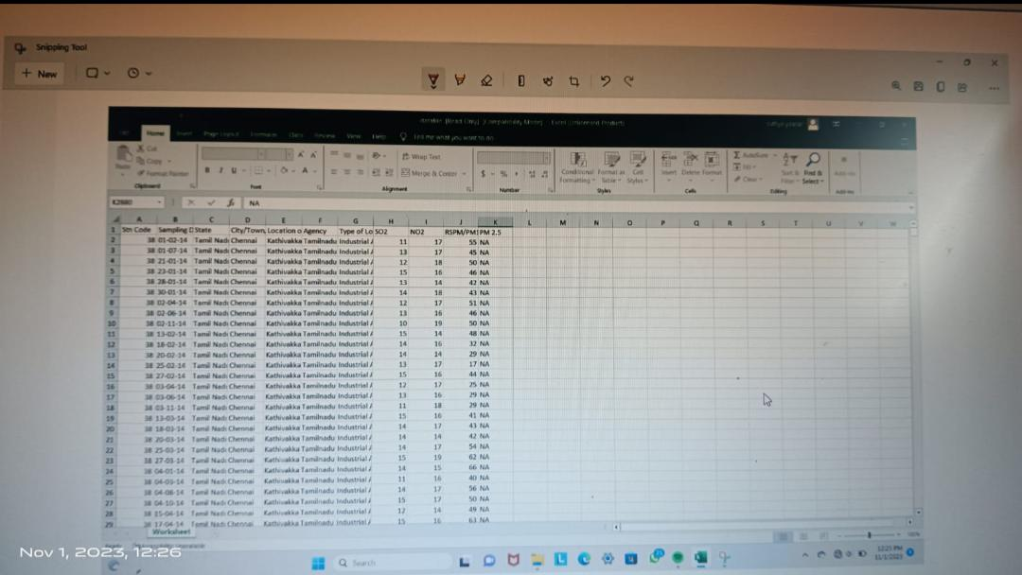The main objective is to record the concentration levels of atmospheric pollutants in order to define air quality levels and establish action plans if high levels of contamination are detected.

**ANALYSIS AND APPROACH OF AIR QUALITY IN TAMILNADU**

To analyze air quality in Tamil Nadu, we should typically follow these steps:

1. Data Collection: Gather air quality data for different locations in Tamil Nadu. This data can be obtained from government agencies, research organizations, or online platforms that provide air quality information.
2. Data Preprocessing: Clean and preprocess the collected data. This may involve removing missing values, handling outliers, and converting data into a suitable format for analysis.
3. Exploratory Data Analysis (EDA): Perform an initial analysis of the data to understand its characteristics. This can include calculating summary statistics, visualizing the distribution of air quality parameters, and identifying any trends or patterns.
4. Spatial Analysis: Analyze the spatial distribution of air quality in Tamil Nadu. This can be done by plotting air quality measurements on a map and identifying areas with high or low pollution levels. Spatial analysis techniques like interpolation can also be used to estimate air quality values at locations where data is not available.
5. Temporal Analysis: Analyze the temporal variation of air quality in Tamil Nadu. This involves studying how air quality parameters change over time, such as daily, monthly, or seasonal variations. Time series analysis techniques can be applied to identify long-term trends, seasonality, and any significant events that may affect air quality.
6. Comparison and Benchmarking: Compare the air quality in different locations within Tamil Nadu and against national or international standards. This helps in identifying areas that require more attention and monitoring.
7. Identify Factors and Sources: Investigate the factors and sources contributing to poor air quality in specific areas of Tamil Nadu. This can involve analyzing meteorological data, industrial activities, vehicular emissions, and other potential sources of pollution.
8. Recommendations and Policy Implications: Based on the analysis findings, provide recommendations for improving air quality in Tamil Nadu. These recommendations can include policy changes, stricter regulations, public awareness campaigns, and initiatives to reduce emissions from specific sources.
9. Monitoring and Evaluation: Establish a monitoring system to track air quality over time and evaluate the effectiveness of any interventions or policies implemented. This allows for continuous improvement and adjustment of strategies to achieve better air quality in Tamil Nadu.

All these above steps are a general approach to air quality analysis and can be customized based on the specific objectives and available data in Tamil Nadu.

**VIRTUALIZATION**

DATA VISUALIZATION WITH IBM COGNOS

Interactive graphs can be created which makes it easier to check air quality, and increasingly diverse colors can visually highlight the air quality level. Visualization of data has a resilient expression (more images and more insightful) than the 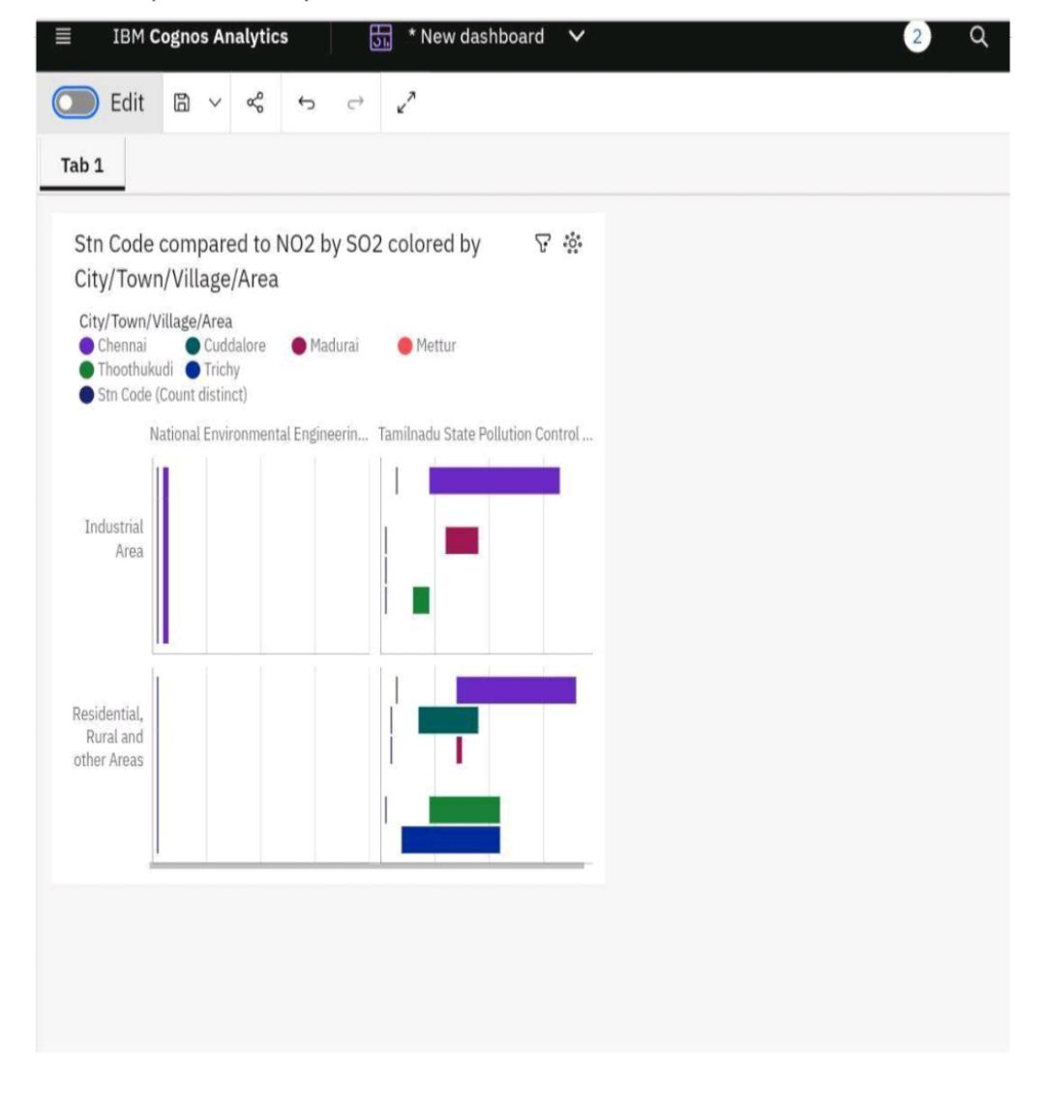original data table, which is favorable for further analysis of data

VISUALIZATION OF DATA

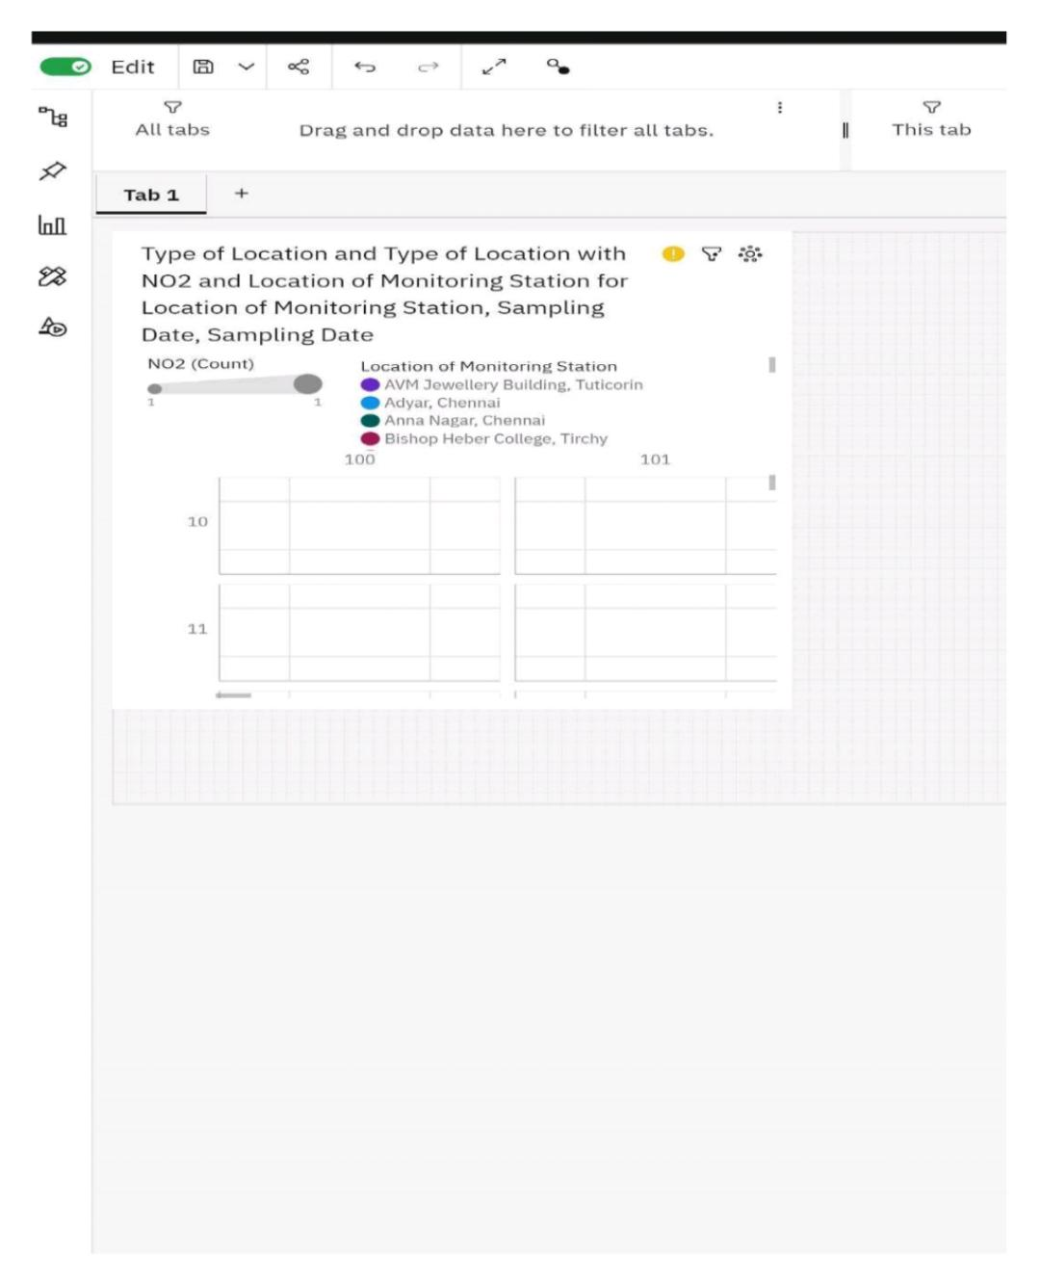

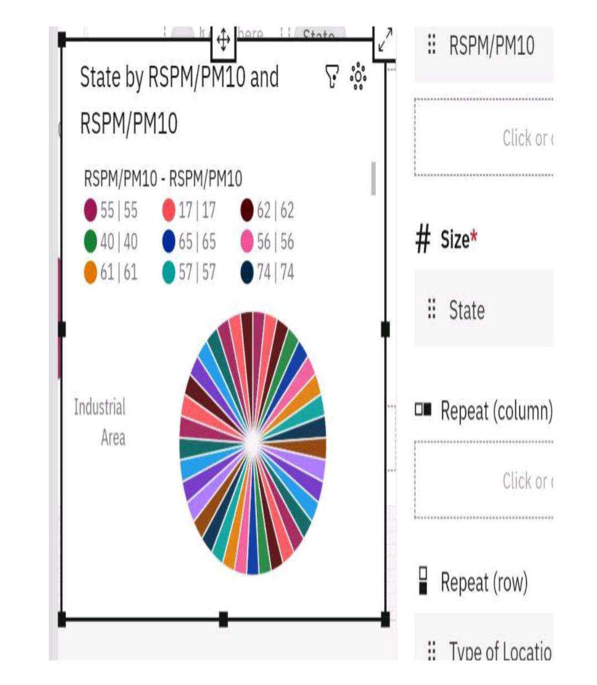Highly polluted states are represented by RSPM/PM10 and RSPM/PM10

**Coding for dataset execution**

To load the dataset of air quality analysis in Tamil Nadu using python, we can follow these steps:

1. Install the necessary libraries:

- pandas: pip install pandas

2. Import the required libraries:

Python

Import pandas as pd

3. Load the dataset:

Python

# Assuming the dataset is in a CSV file format

Dataset_path = ‘path/to/air_quality_dataset.csv’

Df = pd.read_csv(dataset_path)

Make sure to replace ‘path/to/air_quality_dataset.csv’ with the actual path to your dataset file.

To perform air quality analysis and create visualizations using data visualization libraries such as Matplotlib and Seaborn

1. Import the necessary libraries:

Python

Import pandas as pd

Import matplotlib.pyplot as plt

Import seaborn as sns

1. Load the air quality data into a Pandas DataFrame:

Python

Data = pd.read_csv(‘air_quality_data.csv’)

1. Explore the data to understand its structure and available columns:

Python

Print(data.head()) # Display the first few rows of the DataFrame

Print(data.info()) # Get information about the DataFrame

1. Clean and preprocess the data if necessary (e.g., handle missing values, convert data types).
2. Perform analysis on the air quality data using various statistical methods and calculations.
3. Create visualizations using Matplotlib and Seaborn to gain insights from the data. Here are a few examples:
   * Line Plot: Visualize the trend of a specific air quality parameter over time.

Python

Plt.plot(data[‘Date’], data[‘PM2.5’])

Plt.xlabel(‘Date’)

Plt.ylabel(‘PM2.5’)

Plt.title(‘PM2.5 Trend Over Time’)

Plt.show()

* + Histogram: Display the distribution of a particular air quality parameter.

Python

Sns.histplot(data[‘O3’], bins=20)

Plt.xlabel(‘Ozone Level’)

Plt.ylabel(‘Frequency’)

Plt.title(‘Distribution of Ozone Levels’)

Plt.show()

* + Box Plot: Compare the air quality parameters across different categories.

Python

Sns.boxplot(x=’Location’, y=’PM10’, data=data)

Plt.xlabel(‘Location’)

Plt.ylabel(‘PM10’)

Plt.title(‘Comparison of PM10 Levels across Locations’)

Plt.show()

* + Heatmap: Visualize the correlation between different air quality parameters.

Python

Corr_matrix = data[[‘PM2.5’, ‘PM10’, ‘O3’, ‘CO’, ‘SO2’, ‘NO2’]].corr()

Sns.heatmap(corr_matrix, annot=True, cmap=’coolwarm’)

Plt.title(‘Correlation Between Air Quality Parameters’)

Plt.show()

1. Customize the visualizations as per your requirements by adjusting colors, labels, titles, and other parameters.

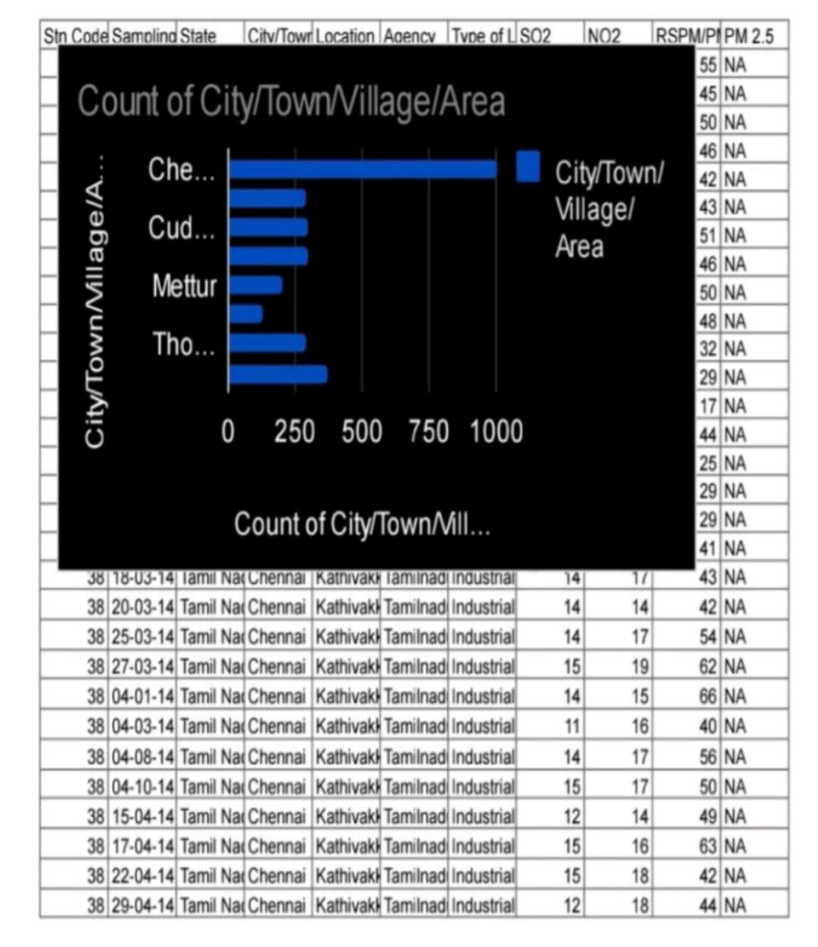**EXAMPLE**

Extracted graph from given dataset

Extracted pie chart for given dataset

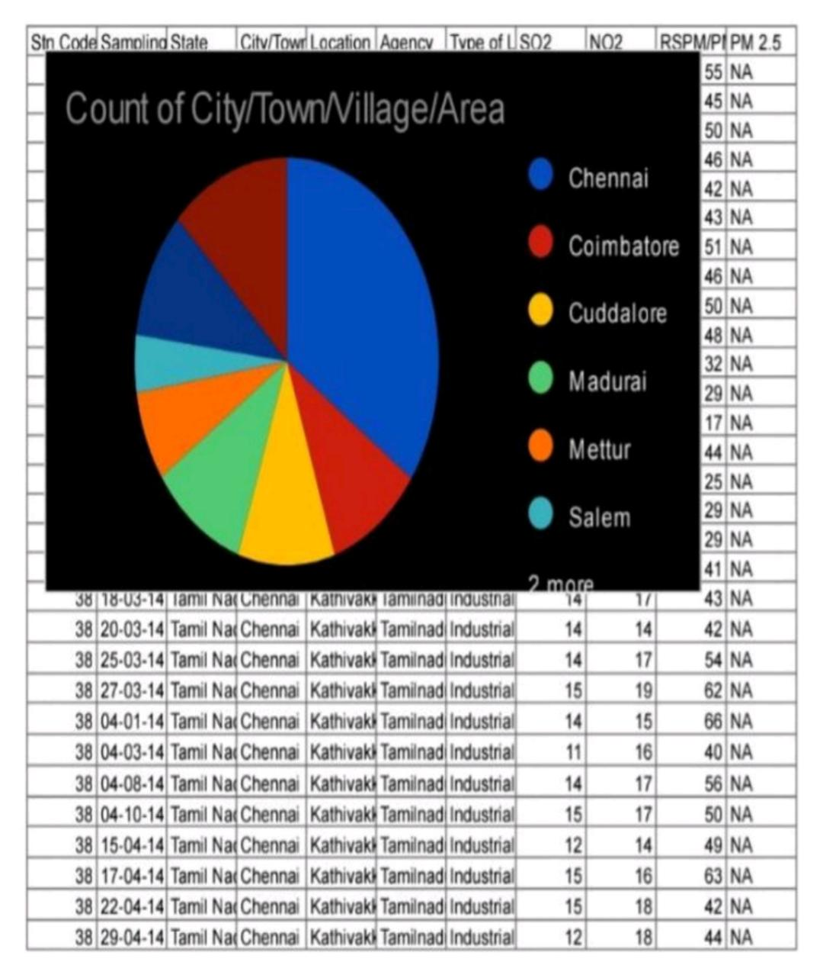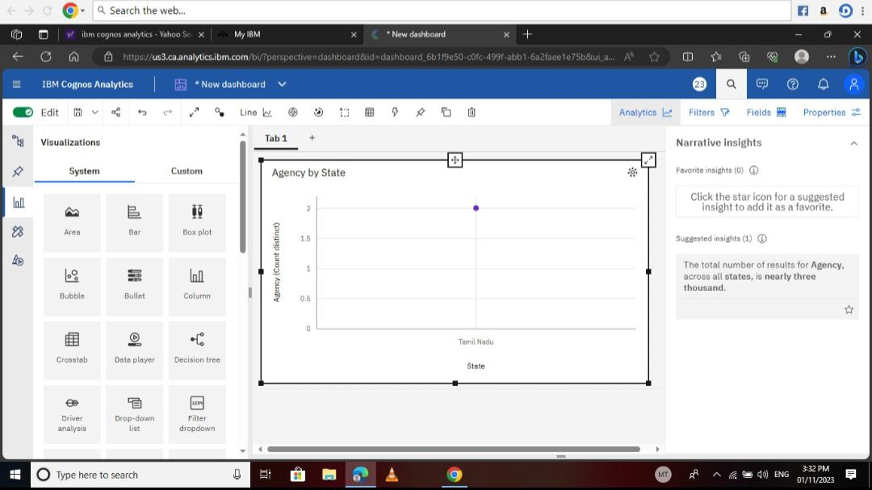**Insights for given dataset**

**DATASET LINK**

https://tn.data.gov.in/resource/location-wise-daily-ambient-air-quality-tamil-nadu-year-2014

**CONCLUSION**

Air pollution is a pressing issue that affects human health, the environment, and the climate system. Taking immediate and effective measures like through air quality analysis we can reduce emissions and promote sustainable practices which are essential to combat this problem it can create a cleaner and healthier future for all.